Procedure for Adjusting the D700 power levels.

- This procedure assumes the user has a copy of the Kenwood D700 Service Manual Document number B51-8504-00(S) 880.
- Fabricate a Service Jig Cable in accordance with the instructions on page 39 of the Service Manual. If the D700 has been modified with the 8 Pin Data connector the Service Jig Cable should have pins 5 and 6 shorted instead of pins 3 and 6 as specified for the 6 pin connector. See Figure 1
- Equipment needed for this procedure includes the following:
  - A Dummy load capable of carrying at least 50 Watts.
  - A power meter capable of measuring 50 Watts at 146Mhz and 440Mhz.
  - A power supply capable of delivering 15 amps at 13.6V D.C.
  - An Ammeter capable of measuring at least 15 Amps. (This may be built into the power supply).
  - Service Jig Cable as described in the previous step.
- Set the Power to a maximum of 25 Watts as described in steps 2.1.3 and 2.2.3 and 2.2.4 as described on pages 49 and 50 of the Service manual. These procedures are included in this document for reference.

Figure 1
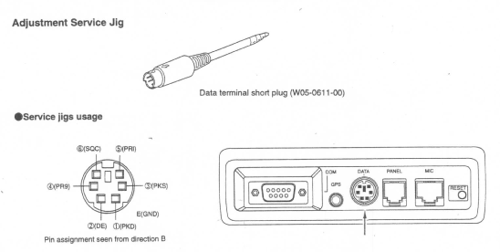

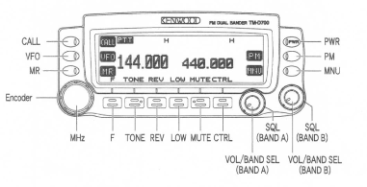

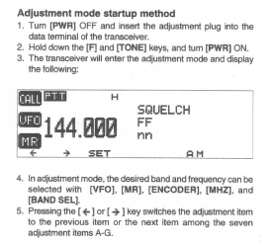

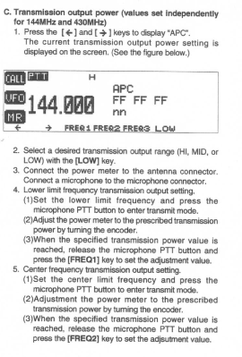
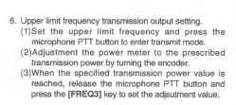
Set the power limits at 5 Watts for LOW, 10 Watts for Medium power and 25 Watts for High Power at frequencies of 144.00 Mhz, 145.00Mhz,146.00Mhz for the 2 meter band and 435.00Mhz,436.5Mhz,438.00Mhz for the 70CM band.

After completion of the procedure, remove the programming plug and cycle the power off.
Power the D700 on and verify the power levels at each of the frequencies and power level settings.

