Suitsat-2/Radioskaf-2: Overview, Technical Description, and Educational Outreach Opportunities
SuitSat-1/Radioskaf-1 caught the attention and fascination of the world, garnering a large amount of newspaper, magazine, radio and TV reporting. Even more important, SuitSat-1 captured the imaginations of students and schools! Amateur astronomers strained their eyes and cameras to get a glimpse of the eerie sight of SuitSat-1/Radioskaf-1 floating in space. Ham radio operators listened for hours to hear its signals. Many sightings and signal reports were posted to a special Web site, proving that sparks of excitement were coming from the public over the space program.
The little satellite was such a success that plans were developed to produce a second SuitSat/Radioskaf. To do this, the international (Amateur Radio on the International Space Station (ARISS) team discussed at their delegates meeting in October 2006. Architect of the first Suitsat/Radioskaf, Sergey Samburov, RV3DR, discussed this idea with the ARISS team and everyone was enthusiastic about the potential of a second SuitSat/Radioskaf.
SuitSat-1/Radioskaf-1 was a simple satellite made from a surplus Russian Orlan spacesuit fitted with a single beacon Amateur Radio transmitter that ran on Russian spacesuit batteries. It had no capability to receive commands, and was destined to live only a short while because it had no solar panels to replenish its batteries. SuitSat-2/Radioskaf-2 is based on SuitSat-1 successes, but there are many enhancements (such as ham radio transponders) being made.
The intent would be for a future ISS Expedition crew to release SuitSat-2/Radioskaf-2 during a space walk. The suit will have a voice ID in a number of languages plus telemetry and these will be transmitted, along with images as it orbits Earth. The unusual spacecraft's radio signal will be heard around the globe.
It is hoped that SuitSat-2/Radioskaf-2 can be launched during a spacewalk as early as October, in conjunction with the 50th anniversary of Sputnik-1. Other possible commemorative occasions could include the 125th birth anniversary of Robert Goddard, and the 150th anniversary of the birth of the famous Konstantin Tsiolkovsky (also the great-grandfather of Sergey Samburov).

Enhanced Capabilities of Suitsat-2/RadioSkaf-2

Suitsat/Radioskaf-2 has all new electronics. It includes all the features of Suitsat/Radioskaf-1 and all the features that were planned but could not be included on Suitsat/Radioskaf-1 due to the launch time pressures. In addition to those features, Suitsat/Radioskaf-2 will have solar panels and a Digital Signal Processor (DSP) for enhanced radio capabilities. It will also have a power system and a transmitter and receiver that are prototypes of those planned for AMSAT’s next satellite, called Eagle.

Primary objective

The primary objective of Suitsat/Radioskaf-2 will be to transmit a message commemorating the 150th birthday of Tsiolkovsky and the 50th anniversary of Sputnik 1. A secondary objective will be to use the suit to serve as a test vehicle to test new systems that are planned for future Amateur Radio satellites and future ISS deployed satellites. It will also carry materials such as photos and document developed through an international educational outreach program.

Suitsat/Radioskaf-2 will build upon the Suitsat/Radioskaf-1 design.

The safety interlock system designed and approved for Suitsat/Radioskaf-1 will be incorporated into Suitsat/Radioskaf-2. There will be a new transmitter and receiver designed to incorporate a down converter that will convert the 70 cm signals down to a 10.7Mhz intermediate frequency and then an up converter to convert the 10.7 Mhz intermediate frequency up to the 2 m transmit frequency. This RF system design will be reusable on future small satellite designs. This system is depicted in the block diagram in Fig.1. This is similar to the system used on larger satellites so it will be a stepping stone for the amateur satellite community. That fits well with AMSAT’s and the ARISS team’s desire to utilize this opportunity to test new designs for future satellites.

Suitsat will have a main computer which is called the Internal Housekeeping Unit (IHU). This computer provides the overall monitoring and control functions needed to keep everything working properly. A block diagram of the IHU is shown in figure 1
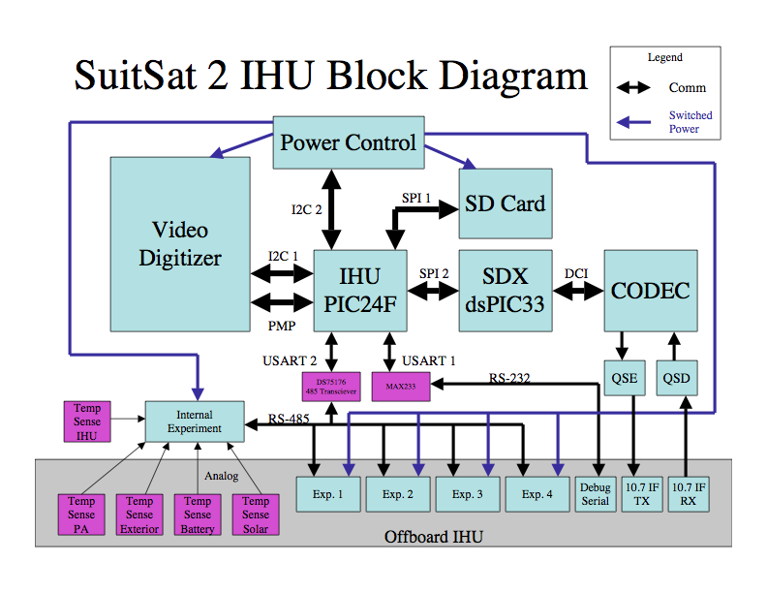
Figure 1

The IHU will also include the same safety interlock circuit that was included in Suitsat/Radioskaf-1. This circuit performed flawlessly on Suitsat/Radioskaf-1 and has been through the NASA safety approval process. The IHU board will also include circuitry to implement the Video and Slow Scan TV (SSTV) system. There will be four cameras on Suitsat/Radioskaf. All will be miniature cameras that will be polled at intervals and the images examined to determine if there is a suitable image in the field of view. If there is a useable image, it will be sent down as a SSTV image. These cameras will only be powered one at a time and at specific intervals. Fig. 2 Suitsat/Radioskaf block diagram.
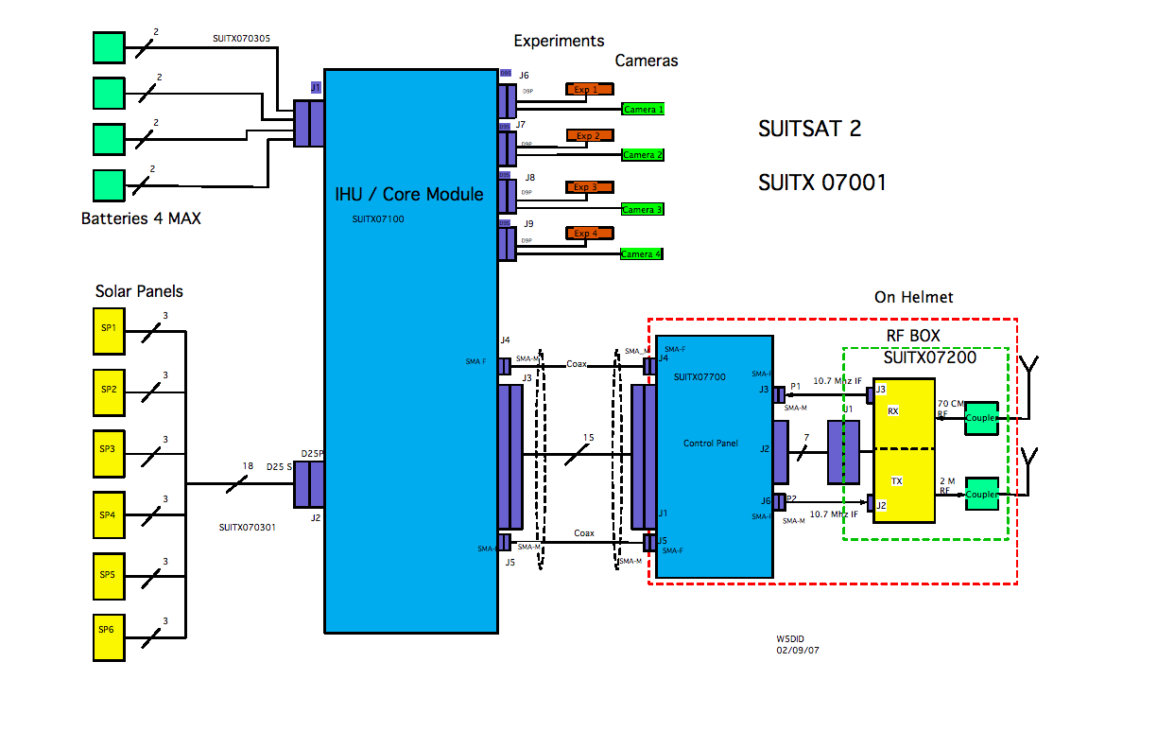
Figure 2

Experiments

There will be four ports for experiments. The experiments will be supplied with constant 12V DC power. There will be a signal at regular intervals that tells the experiment that it can now download data to the IHU. Since this is a very low power satellite the power supplied will be small. A document will be developed that specifies the interface requirements and limitations.

Radio

The Suitsat/Radioskaf-2 transmitter and receiver will be based on a Software Defined Transponder (SDX) system. It will consist of two major components: the RF Module and the Digital Signal Processor (DSP) module. In the RF module there will be an up converter that receives a signal from the DSP module as a 10.7 Mhz intermediate Frequency RF signal with a 50 Khz bandwidth and up converts it to 145 Mhz signal of 50 KHz bandwidth centered on 145.9375 Mhz.

The receiver is a down converter with a 50K Hz bandwidth centered on 437.6125 MHz.
The output of the receiver is a 10.7 MHz RF signal with a bandwidth of 50Khz.

The DSP processor receives the 10.7MHz signal from the receiver down converter and processes it and outputs a 10.7MHz signal to the transmitter up converter. The DSP can also inject signals such as the CW ID, Telemetry,, audio and packet signals as determined by the software on the DSP. The proposed Suitsat/Radioskaf-2 band plan is shown in figure 3.
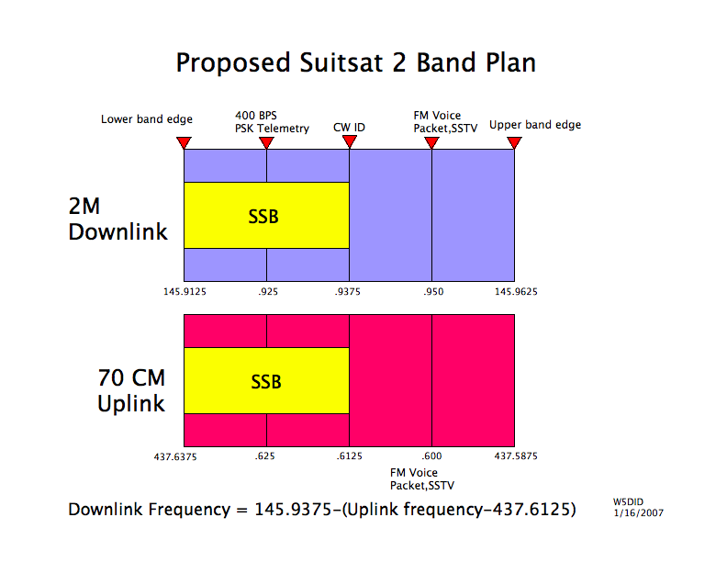

Solar Power System

The Solar Power System consists of three major systems. The Solar Panels, the Maximum Power Point Converter and the Batteries. The Solar panels we plan to use are NASA developed panels that have flown on several different NASA satellites. They were intended to be used as generic panels that were available to any new satellite being developed for the NASA Small Explorer (SMEX) program. When the program was in operation, these were state of the art panels. The SMEX program is no longer in operation and these are surplus panels for our use. They are in excellent shape and are being made available for use on Suitsat/Radioskaf-2. They will need to be modified and the AMSAT team can do the modifications. The panels will need to be mounted on the exterior of the Russian Orlan suit. There will be six panels to mount. Each needs to be facing a different direction so that power is received regardless of the orientation of the suit. A block diagram of the power system is shown figure 4.

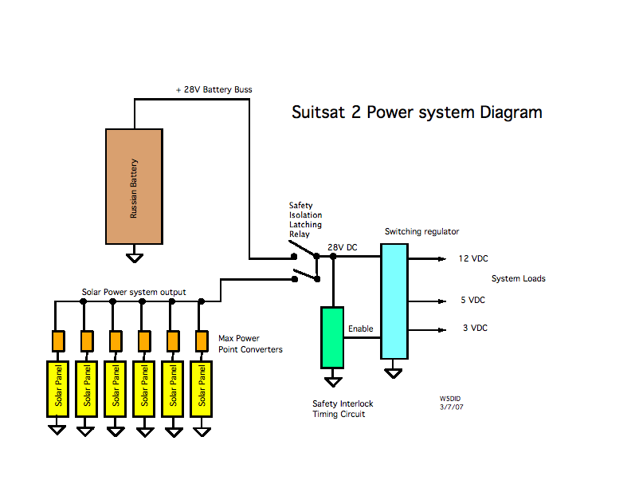
Figure 4

These panels can provide 19 watts each when facing the sun. As configured they can provide about 5 watts average power over an entire orbit if operation during eclipse (Nightime) is included.

Educational Outreach.

SuitSat/Radioskaf-2 will be an even greater force for educational outcomes than was SuitSat/Radioskaf-1. Schoolteachers have designed three levels of lesson plans about technology and space for children as young as 5 years old, and up to 18 years old. For older students and the general public, there will be activities, lectures and resource materials. Bob Twiggs, director of the Space & Systems Development Lab at Stanford University’s Department of Aeronautics & Astronautics has been asked to assist. These many educational activities will be posted to the special SuitSat Web site; which has been constructed with basic information, and is awaiting materials.
Voice messages from all over the world will be solicited in order for SuitSat/Radioskaf-2 to include global greetings. Students’ creative materials and classroom technical work will be solicited, and will travel into space with SuitSat/Radioskaf-2.
Scouts have assisted with assembling the circuitry boxes for the radio system. College students have designed and tested some of the SuitSat/Radioskaf-2 circuits.
Plans are being made for garnering publicity for SuitSat/Radioskaf-2. The SuitSat Web site will update readers on all aspects of the mission. The Web site for SuitSat/Radioskaf-1 attracted nearly 10 million hits during its mission!
Suitsat.Radioskaf-2 development and project responsibilities

At a meeting at the NASA Goddard Space Flight Center the joint Russian and American teams agreed to the following list of responsibilities:

The Russian team will supply a Russian Orlan spacesuit already on board the ISS, which has exceeded its useful lifetime, as a housing unit for the amateur radio system.

Six solar panels will be provided by U.S. team, obtained from The NASA SMEX program at GSFC.

The Russian partners will be responsible for designing the mounting, deployment, safety and associated crew training required for the Solar panel system.

A Maximum Power Point converter will be provided by the U.S. partner.

The Russian team will supply one new 28VDC battery of the same type that is certified for use on the Russian Orlan suit for SuitSat-2 and a second battery to the U.S. team to be used for testing and development.

The Russian team will provide the information necessary to design the battery charging system.

The U.S. team is responsible for defining all commands and telemetry.

The U.S. team is responsible for command and telemetry formats and protocols.

The U.S. team will provide 2 center feed V antennas and associated preamps and power amps.

The Russian partner is responsible for mounting the antenna, preamp and power amp.

The U.S. team will develop and certify for flight the Internal Housekeeping Unit (IHU) with interfaces.

The U.S. team will provide and certify for flight 4 cameras.

The U.S. team will develop and provide procedures and diagrams for assembling/connecting the U.S. delivered components to our Russian partner.

The Russian team will develop the procedures for the full assembly of SuitSat-2 on board the ISS.

Schedule

U.S. team will deliver hardware to Energia in September 2007.

